CoreChain
B2B Inventory & Supply Chain Management System
Deliverable #2 | Iteration 2 / Sprint 2

Course: Fundamentals of Software Engineering / DB Systems Lab | Sprint: Sprint 2 (April 2026)

Member | Roll No.
Muhammad Asjad | L24-2570
Hamza Sheikh | L24-2500
M. Abuzar Rizwan | L24-2535

a. Project Title & Introduction

Project Title: CoreChain

CoreChain is a centralized B2B Inventory and Supply Chain Management platform built to optimize warehouse operations, track product lifecycles, and automate order processing. Sprint 2 builds upon the foundational architecture established in Sprint 1 and delivers five fully implemented operational modules: Purchase Order Management, Sale Order Management, Warehouse Management, Product & Category Management, and Staff Management — covering both backend APIs and frontend interfaces.

Sprint 1 established the core infrastructure including User Authentication, Business Management, and Supplier Management. Sprint 2 completes the primary operational modules, enabling end-to-end inventory and supply chain operations within the CoreChain platform.

b. Sprint Backlog & User Stories

Module Scope
Modules completed in Sprint 2: Purchase Order Management, Sale Order Management, Warehouse Management, Product & Category Management, Staff Management

US-04 Purchase Order Management |  | Story Points: 14
As a Business Manager, I want to create and manage purchase orders from suppliers so that I can track inbound inventory efficiently.
Sub-Story | Description | Points
SS-4.1 | As a Manager, I want to create a new purchase order linked to a supplier and warehouse. | 3 pts
SS-4.2 | As a Manager, I want to add multiple line items (products, quantity, unit cost) to a purchase order. | 3 pts
SS-4.3 | As a Manager, I want to update the status of a purchase order (Pending, Approved, Received, Cancelled). | 3 pts
SS-4.4 | As a Manager, I want to view the full list of purchase orders with filters by status and supplier. | 3 pts
SS-4.5 | As a Manager, I want to cancel or soft-delete a purchase order while retaining audit history. | 2 pts

US-05 Sale Order Management |  | Story Points: 14
As a Business Manager, I want to create and manage sale orders for customers so that I can track outbound inventory and revenue.
Sub-Story | Description | Points
SS-5.1 | As a Manager, I want to create a new sale order with customer information and warehouse source. | 3 pts
SS-5.2 | As a Manager, I want to add line items (products, quantity, unit price) to a sale order. | 3 pts
SS-5.3 | As a Manager, I want to update the status of a sale order (Pending, Confirmed, Shipped, Delivered, Cancelled). | 3 pts
SS-5.4 | As a Manager, I want to view and filter all sale orders by status and date range. | 3 pts

US-06 Warehouse Management |  | Story Points: 11
As a Business Owner or Manager, I want to manage warehouse locations so that I can organize inventory across multiple physical sites.
Sub-Story | Description | Points
SS-6.1 | As an Owner, I want to register a new warehouse with a name, address, and business association. | 3 pts
SS-6.2 | As a Manager, I want to update warehouse details including name and address. | 2 pts
SS-6.3 | As a Manager, I want to assign or remove staff members from a warehouse with specific roles. | 3 pts
SS-6.4 | As a Manager, I want to deactivate a warehouse using a soft-delete while retaining historical data. | 3 pts

US-07 Product & Category Management |  | Story Points: 13
As a Business Manager, I want to manage the product catalog and categories so that I can maintain accurate and organized inventory records.
Sub-Story | Description | Points
SS-7.1 | As a Manager, I want to create a new product with a unique SKU, price, and category assignment. | 3 pts
SS-7.2 | As a Manager, I want to update product information including price and category. | 2 pts
SS-7.3 | As a Manager, I want to link products to one or more suppliers for procurement flexibility. | 3 pts
SS-7.4 | As a Manager, I want to view real-time stock levels per product per warehouse. | 2 pts

US-08 Staff Management |  | Story Points: 10
As a Business Owner, I want to manage my staff members and their roles so that I can control access and responsibilities within the platform.
Sub-Story | Description | Points
SS-8.1 | As an Owner, I want to view all active and inactive staff members in my business. | 2 pts
SS-8.2 | As an Owner, I want to update a staff member's assigned role within the business. | 3 pts
SS-8.3 | As an Owner, I want to deactivate a staff member's access without deleting their records. | 3 pts
SS-8.4 | As an Owner, I want to assign staff members to specific warehouses with designated roles. | 2 pts

c. Structured Specifications

Specification 1 — Create Purchase Order
Actor / User | Business Manager
Pre-condition | Manager is authenticated and logged into the CoreChain dashboard. At least one active supplier and one active warehouse exist.
Post-condition | A new PurchaseOrder record is created with Status = 'Pending'. Line items are added to PurchaseOrderItem. Inventory is updated upon status change to Received.
Main Flow | Manager navigates to Purchase Orders > Create New. Selects supplier, warehouse, and adds line items with product, quantity, and unit cost. Submits the order.
Alt. Flow | If a selected product is not linked to the chosen supplier, a warning is shown. Manager can override and proceed.

Specification 2 — Create Sale Order
Actor / User | Business Manager
Pre-condition | Manager is authenticated. Products with sufficient inventory exist in the selected warehouse.
Post-condition | A new SaleOrder record is created with Status = 'Pending'. Inventory is decremented upon order confirmation.
Main Flow | Manager navigates to Sale Orders > Create New. Enters customer name, selects warehouse, adds line items with product and quantity. Submits the order.
Alt. Flow | If inventory is insufficient for a line item, an error is displayed and the order cannot be submitted until resolved.

Specification 3 — Register a New Warehouse
Actor / User | Business Owner / Manager
Pre-condition | User is authenticated with Owner or Manager role. The business account is active.
Post-condition | A new Warehouse record is created and linked to the business. IsActive = TRUE.
Main Flow | User navigates to Warehouses > Add New. Enters warehouse name and address. Submits the form.
Alt. Flow | Duplicate warehouse names within the same business trigger a 409 conflict validation error.

Specification 4 — Add a New Product
Actor / User | Business Manager
Pre-condition | Manager is authenticated. At least one product category exists in the system.
Post-condition | A new Product record is created with a unique SKU linked to the business. An Inventory record is initialized at 0 for each active warehouse.
Main Flow | Manager navigates to Products > Add New. Enters product name, SKU, selling price, and selects a category. Optionally links to suppliers. Submits the form.
Alt. Flow | If the SKU already exists within the business, a conflict error (409) is returned and the form is not submitted.

Specification 5 — Manage Staff Roles & Access
Actor / User | Business Owner
Pre-condition | Owner is authenticated. The target staff member exists and is active within the business.
Post-condition | The staff member's RoleID is updated in the Staff table. Access permissions are adjusted on next login.
Main Flow | Owner navigates to Staff Management. Selects a staff member and updates their role from the dropdown. Saves changes.
Alt. Flow | An Owner cannot demote themselves or deactivate the sole Owner account of the business.

d. Sprint 2 Implementation

The following section documents the working implementation of Sprint 2. All backend APIs were built with Node.js using a modular MVC pattern (controllers / queries / routes). The frontend was built using React, covering all five operational modules delivered in this sprint.

Sprint Board — Trello
The following screenshots show the Sprint 2 Trello board tracking task progress across the sprint lifecycle. Tasks were categorized as Sprint 2 Backlog, In Progress, Testing, and Completed.

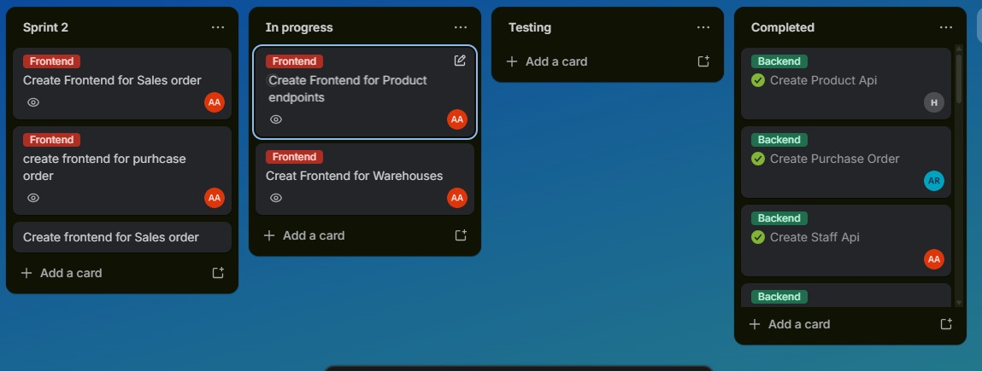
Figure 1: Sprint 2 Trello Board — Initial Task Distribution

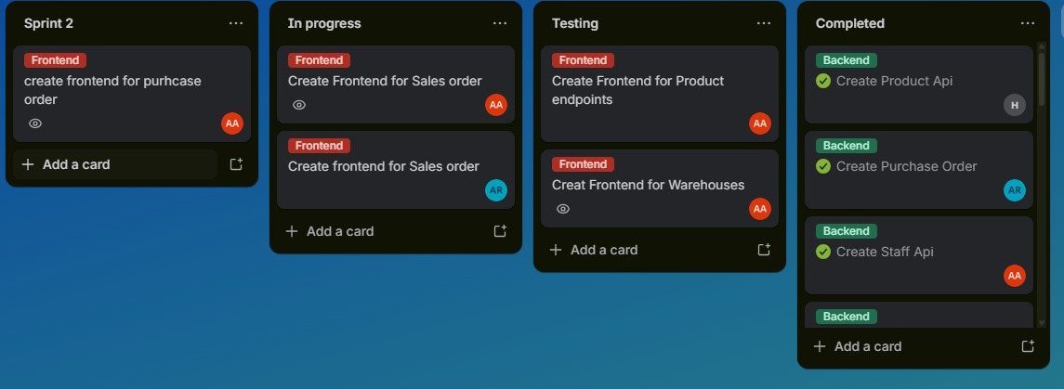
Figure 2: Sprint 2 Trello Board — Updated Progress State

Backend — API Structure
The backend continues the modular MVC architecture from Sprint 1. Each new module contains a controller (business logic), a queries file (raw SQL), and a routes file (Express endpoints). JWT-based authentication middleware is enforced on all protected routes.

Module | Files | Endpoints Implemented
purchaseOrder | controllers, queries, routes | GET /list, POST /create, PUT /update/:id, PATCH /status/:id, DELETE /:id
saleOrder | controllers, queries, routes | GET /list, POST /create, PUT /update/:id, PATCH /status/:id, POST /return
warehouse | controllers, queries, routes | GET /list, POST /create, PUT /update/:id, POST /assign-staff, PATCH /deactivate/:id
product | controllers, queries, routes | GET /list, POST /create, PUT /update/:id, POST /link-supplier, GET /stock/:id
category | controllers, queries, routes | GET /list, POST /create, PUT /update/:id, DELETE /:id
staff | controllers, queries, routes | GET /list, PATCH /role/:id, PATCH /deactivate/:id, POST /assign-warehouse

Frontend — React Pages Implemented
The React frontend implements all five Sprint 2 modules. Each page communicates with the backend via Axios API calls. Routing uses React Router with role-based protected routes ensuring only authorized staff can access sensitive management pages.

Page | Route | Description
Purchase Orders | /purchase-orders | Lists all purchase orders with status filters. Links to detail view and create form.
Create Purchase Order | /purchase-orders/new | Dynamic form to create a PO with supplier, warehouse, and line items. Calls POST /purchaseOrder/create.
Sale Orders | /sale-orders | Lists all sale orders with status and date range filters.
Create Sale Order | /sale-orders/new | Form for new sale order with customer info, warehouse, and line items. Validates stock availability.
Warehouses | /warehouses | Warehouse directory with add, edit, and deactivate controls. Displays assigned staff.
Products | /products | Product catalog with stock levels, SKU, and category. Supports search and filter.
Categories | /categories | Hierarchical category management with parent-child tree structure.
Staff Management | /staff | Lists all staff with role badges. Owner can update roles, deactivate accounts, and assign to warehouses.

Database — Tables Active in Sprint 2
The full 20-table schema deployed in Sprint 1 remains active. Sprint 2 activates and populates the operational tables that were previously defined but unused. All foreign key constraints and soft-delete patterns continue to be enforced.

Table Name | Key Columns | Purpose
Warehouse | WarehouseID, WarehouseName, Address, BusinessID, IsActive | Physical warehouse locations per business
Staff_Warehouse | StaffID, WarehouseID, RoleID (composite PK) | Staff assignment to warehouses with roles
Category | CategoryID, CategoryName, ParentCategoryID (self-ref) | Hierarchical product categories
Product | ProductID, SKU (unique), CategoryID, SellingPrice, BusinessID | Product catalog with per-business unique SKU
Product_Supplier | ProductID + SupplierID (composite PK) | Many-to-many product to supplier mapping
Inventory | WarehouseID + ProductID (PK), Quantity, LowStockThreshold | Real-time stock levels per warehouse
PurchaseOrder | POID, SupplierID, WarehouseID, Status, CreatedBy | Inbound procurement orders from suppliers
PurchaseOrderItem | POItemID, POID, ProductID, Quantity, UnitCost, TotalCost | Line items for purchase orders
SaleOrder | SOID, BusinessID, WarehouseID, CustomerName, Status | Outbound customer sale orders
SaleOrderItem | SOItemID, SOID, ProductID, Quantity, UnitPrice, TotalPrice | Line items for sale orders
ProductReturn | ReturnID, SOID, ProductID, Quantity, Reason, Status | Customer return processing linked to sale orders
Staff | StaffID, UserID, BusinessID, RoleID, IsActive | Maps users to businesses with role and active status
AuditLog | LogID, TableName, ActionType, RecordID, ChangedBy | Full audit trail for all data changes

e. Non-Functional Requirements (NFR)

Category | Requirement
Security | Multi-tenant isolation is strictly enforced. A user from Business A can never access data belonging to Business B. All BusinessID filters are applied server-side. JWT tokens expire and are validated on every protected route. Role-based access control (RBAC) restricts module access based on staff role (Owner vs Manager).
Performance | Standard CRUD operations must execute in under 1.5 seconds under normal load. Order listing queries use indexed columns (BusinessID, WarehouseID, SupplierID, Status) for efficient filtering. Paginated responses are returned for large datasets to maintain UI responsiveness.
Usability | All API responses return clear, actionable error messages with appropriate HTTP status codes (400, 401, 403, 404, 409, 500). Frontend pages provide inline validation feedback before submission. Order forms dynamically calculate line item totals and validate inventory availability in real time.
Data Integrity | Database enforces all relational constraints via foreign keys. Soft-deletes (IsActive = FALSE) are used over hard-deletes to preserve historical order and staff data. Inventory updates are atomic — stock changes are only committed upon confirmed order status transitions.
Scalability | The modular MVC architecture allows new modules to be added without affecting existing ones. The warehouse and inventory model supports multi-location businesses with independent stock tracking per site. The product-supplier many-to-many relationship allows flexible procurement configurations.

